
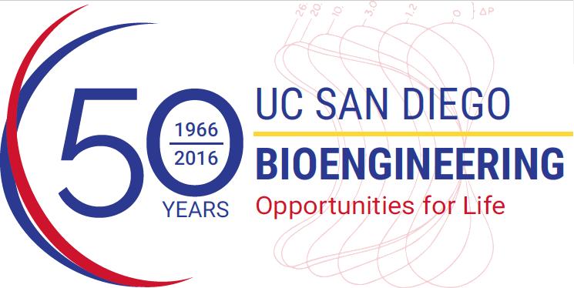
BENG281 Seminar

Katja Lamia
Assistant Professor
Department of Chemical Physiology
The Scripps Research Institute



Circadian Clocks Modulate Metabolism and Cellular Transformation via Complex Transcription Networks

Abstract:
Circadian clocks modulate a wide variety of cellular and physiological functions including metabolism and genome protection in a time-of-day dependent manner. Mammalian circadian clocks involve a transcription and translation feedback loop in which the transcription factors Clock and Bmal1 drive expression of period (Per1-3) and cryptochrome (Cry1,2) repressors, which inhibit Clock:Bmal1, resulting in oscillating transcription. My laboratory has discovered several pathways by which Cry1 and Cry2 mediate circadian responses to extracellular stimuli by regulating the activity of transcription factors, including several nuclear hormone receptors. We have also developed tools to elucidate the pathways by which Cry1 and Cry2 integrate extracellular signals to effect transcriptional networks that alter metabolic and proliferative capacity.

Biography:
Katja Lamia is an Assistant Professor in the Department of Chemical Physiology at The Scripps Research Institute in La Jolla, CA. Katja’s research program is focused on the mechanisms by which mammalian circadian clocks modulate metabolism and cellular proliferation and transformation by regulating a multitude of sequence-specific DNA binding transcription factors. Her group has made key advances in understanding the function of mammalian cryptochrome proteins, which are evolutionarily derived from light-sensing DNA repair enzymes and have adapted to respond to metabolic signals rather than light and to indirectly modulate cellular physiology via transcriptional regulation. Katja has been honored with a Searle Scholars Award from the Kinship Foundation and a Sidney Kimmel Cancer Research Scholar Award.

